Red Cloud Community Schools
Annual Report to the Patrons

January 2024

Mission Statement

Believe – Achieve – Succeed

Administration

Brian Hof – Superintendent

Jason Heldt – High School Principal
Amy Dallman – Elementary Principal

School Contact Information

WASHINGTON HIGH SCHOOL LINCOLN ELEMENTARY

121 West 7th Avenue 334 North Cherry Street

Red Cloud, NE 68970 Red Cloud, NE 68970

Phone: 402-746-2818 Phone: 402-746-3413
Fax: 402-746-2817 Fax: 402-746-3690

General Information

Red Cloud Community Schools is a Class III school that is accredited by the Nebraska Department of Education under the Nebraska Frameworks for grades Kindergarten through Six, and the North Central Association on Accreditation and School Improvement for grades 7 through 12. The school is a member of the Twin Valley Conference that includes: Blue Hill, Deshler, Franklin, Harvard, Kenesaw, Lawrence/Nelson, Red Cloud, Shelton, and Silver Lake.

The District is governed by a six-member Board of Education. Each member is elected for a four-year term. Board members must be residents of School District 91-0002 and each member serves the district with no compensation for their services. The Board of Education must hold a regular meeting by the third Monday of each month. Board meetings are normally held in the library at Lincoln Elementary. All board meetings are open to the public and are advertised according to state open meeting laws. Public notice of meetings is placed in the Red Cloud Chief. Current board members include: Jeff Armstrong—president, Val Horne—vice-president, Liz VanWey—secretary, Ben Hobbs—treasurer and members Robin Peterson and Jeff Ord.

Staffing

Three administrators, Mr. Brian Hof, Superintendent, Mrs. Amy Dallman, Elementary School Principal, and Mr. Jason Heldt, High School Principal, serve Red Cloud Community Schools. Mr. Hof is in his sixth year at Red Cloud and Mrs. Dallman and Mr. Heldt are in there second year in the system as principals. The superintendent’s contract is for 11 months and the principals are on a 10-month contract. Principals are required to hold a Masters Degree with an endorsement as a school principal. The Superintendent has an Educational Specialist Degree with certification as a School Superintendent. Mr. Heldt and Mrs. Dallman holds a Masters Degrees in School Administration. Mr. Hof holds an Educational Specialist Degree from the University of Nebraska at Kearney, a Masters Degree in Administration from the University of Nebraska at Kearney, a second Masters Degree in Counseling and Psychology from the University of South Dakota, as well as a Bachelors Degree from Black Hills State University.

In addition to the administrative staff, 24 certificated teachers serve the school. Teachers are contracted for 185 days of service; one teacher has a 213-day contract; two have a 203-day contract and one a 193-day contract. Teachers must hold a minimum of a Bachelor Degree with proper endorsements in their educational teaching field.

The support staff consists of 22 full- and part-time employees. Included are two secretaries, one bookkeeper, one Registered Nurse, nine Para-professionals, three cooks, and three maintenance personnel. The district contracts with an outside company to provide bussing.

The school contracts with Central Nebraska Rehab Services for Speech Language/occupational/diagnostic/evaluation services. The sports physical therapy is contracted through New West. Red Cloud Community Schools provides services for Resource with Red Cloud Community School employees.

2022-23 Enrollment Figures

Grade Total
Kindergarten 17
First Grade 18
Second Grade 19
Third Grade 13
Fourth Grade 22
Fifth Grade 14
Sixth Grade 15
Seventh Grade 23
Eighth Grade 19
Ninth Grade 17
Tenth Grade 19
Eleventh Grade 11
Twelfth Grade 19

TOTAL K-12 ENROLLMENT 226

Recent K-12 Membership Data
Year Elem. Sec. Total
2002-03 124 126 250
2003-04 118 136 254
2004-05 124 125 249
2005-06 130 112 242
2006-07 134 125 259
2007-08 114 113 227
2008-09 106 110 216
2009-10 116 102 218
2010-11 117 111 228
2011-12 111 116 227
2012-13 117 121 238
2013-14 120 100 220
2014-15 129 93 223
2015-16 124 78 202
2016-17 127 78 205
2017-18 129 73 202
2018-19 132 82 214
2019-20 122 87 209
2020-21 129 101 230
2021-22 117 109 226
2022-23 99 106 205

K-12 MOBILITY RATE DATA

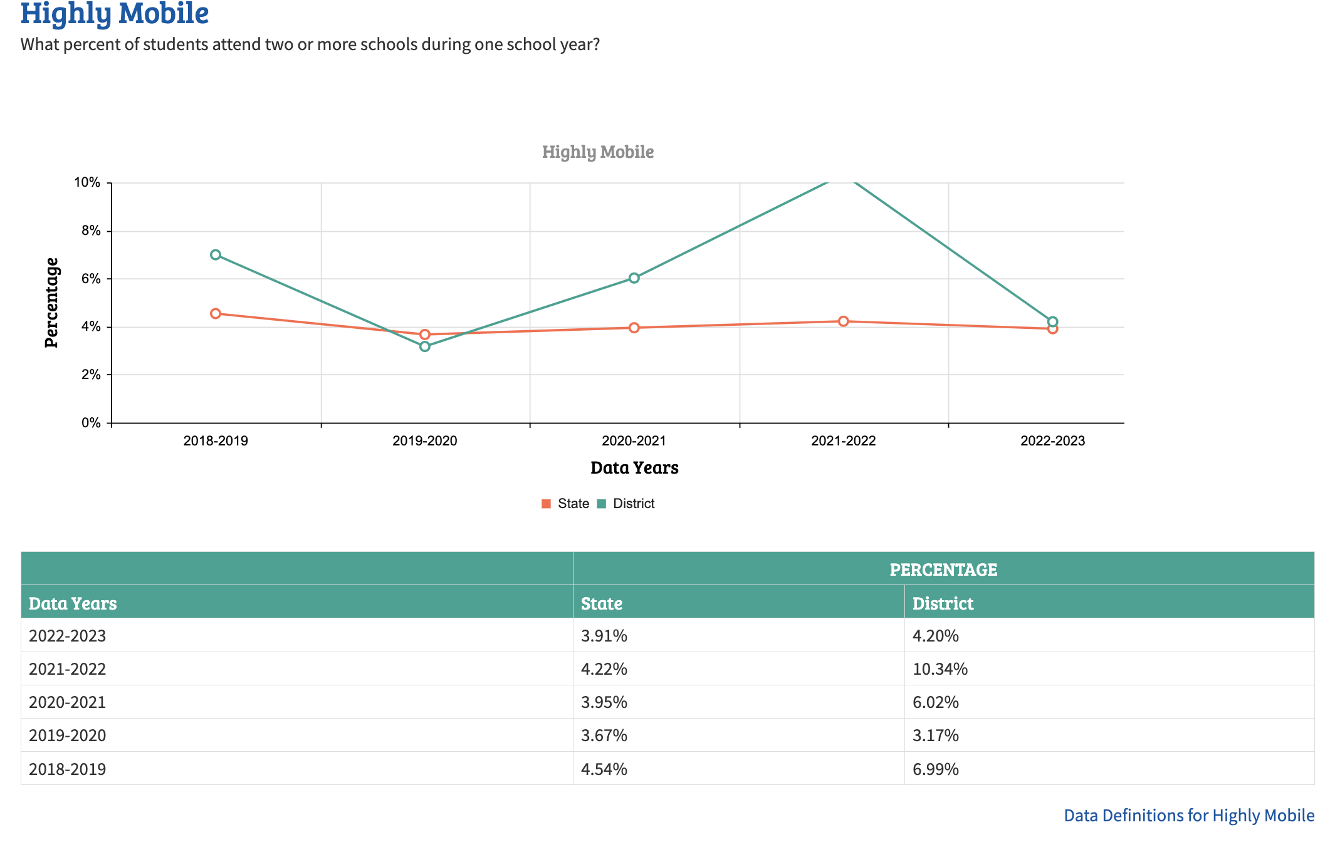

GRADUATION RATE DATA

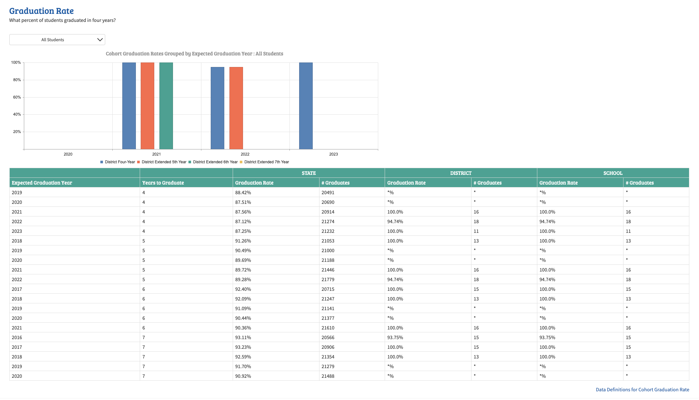

STUDENT CHARACTERISTICS

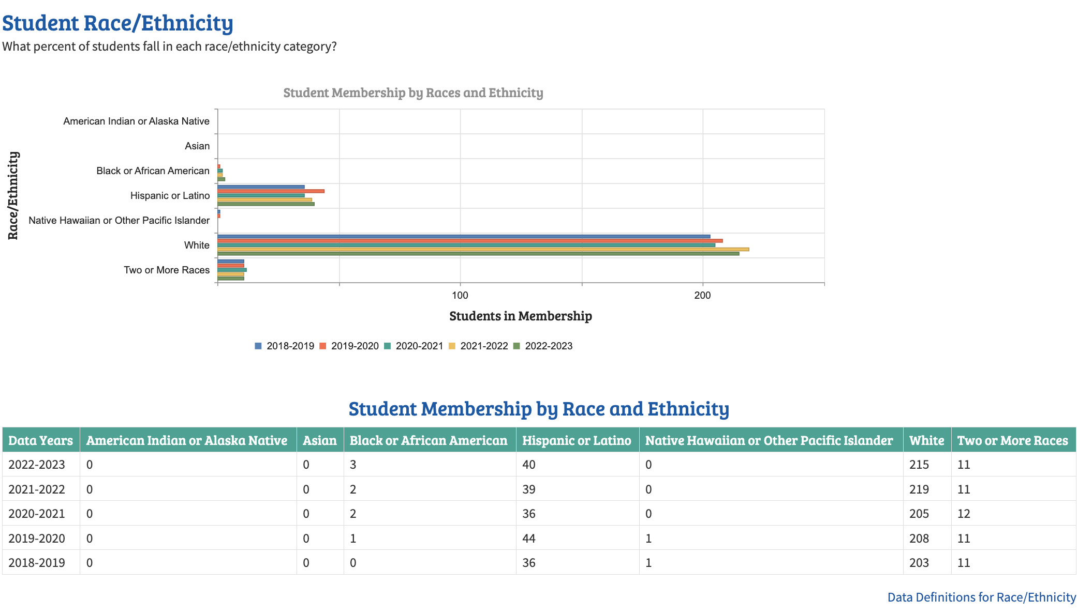
K-12 ATTENDANCE RATE DATA

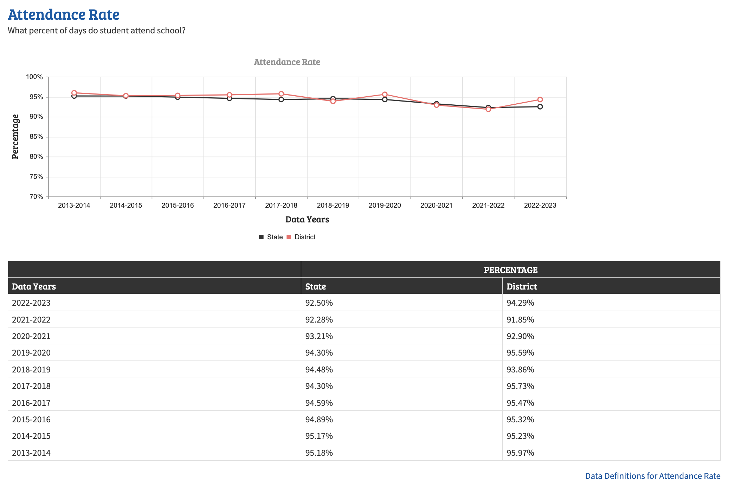

Red Cloud Graduation Requirements
Subject Hours Classes Required
Language Arts 40 English 9
English 10
English 11
One course as a senior
not previously taken

Social Studies 30 World Geog./World History
US History
US Government

Mathematics 30 Algebra I

Science 30 Physical Science
Biology

Vocational Education 40

Personal Health & Fitness 10 PE/Health 9

Electives 80

TOTAL CREDIT HRS.

FOR GRADUATION 260

STANDARDIZED TEST RESULTS

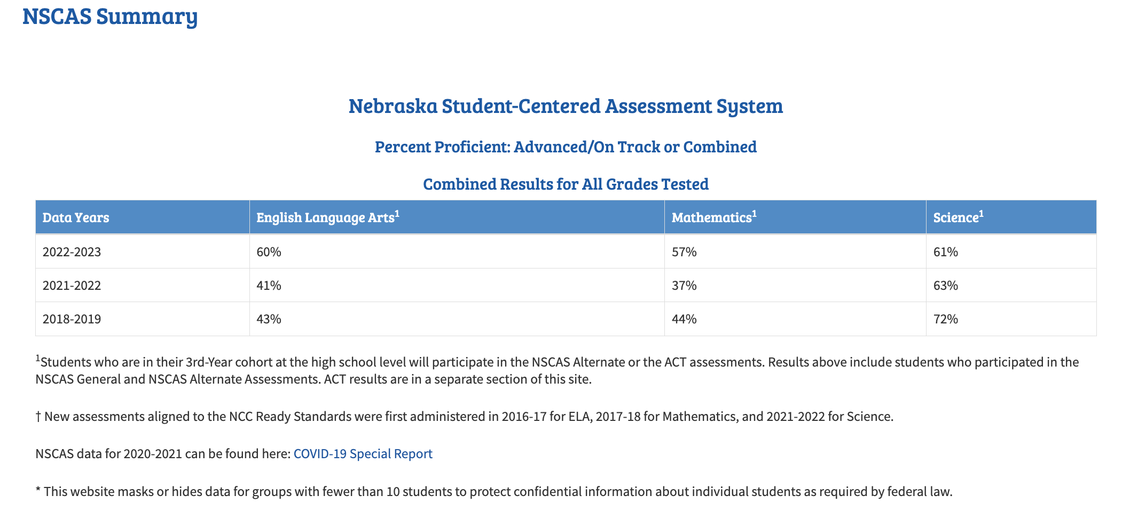

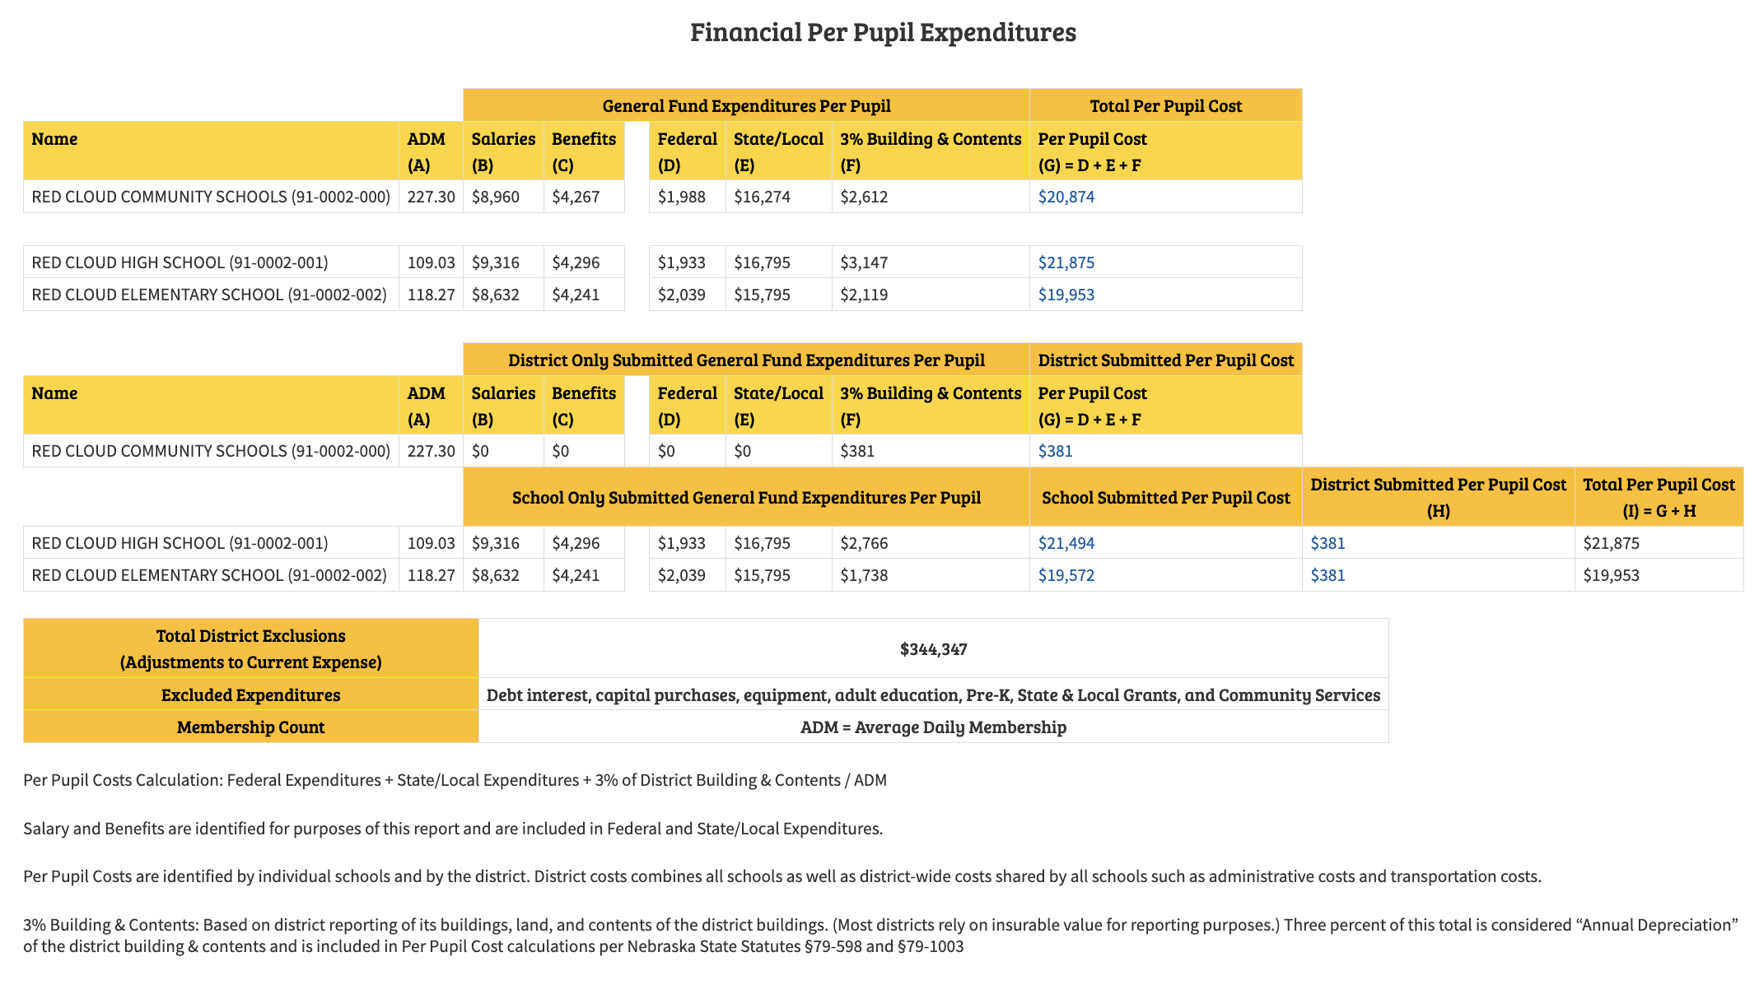

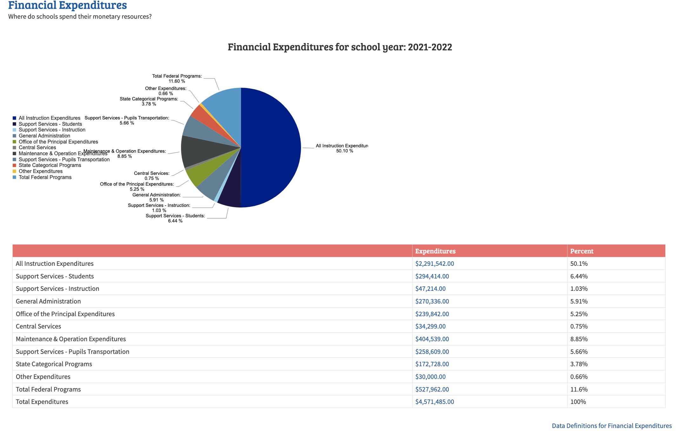

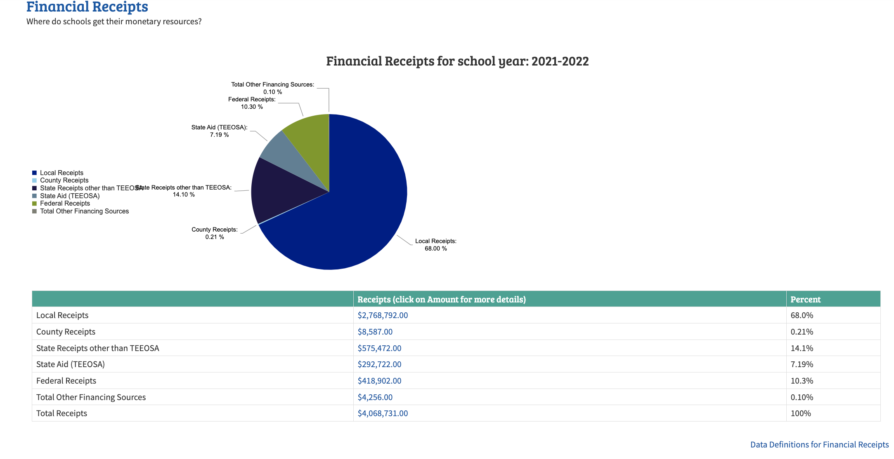

Recent Mill Levy Data
Year General Fund Building Fund Total
2004-05 .9611 .1293 1.0904
2005-06 1.0498 .1319 1.1817
2006-07 1.0701 .0045 1.0746
2007-08 1.0676 .0074 1.0750
2008-09 1.0209 .0283 1.0492
2009-10 1.0067 .0427 1.0494
2010-11 1.0070 .0421 1.0491
2011-12 1.0107 .0377 1.0484
2012-13 1.0498 .0000 1.0498
2013-14 1.0293 .0204 1.0497
2014-15 1.0499 .0000 1.0499
2015-16 0.8945 .1054 0.9999
2016-17 0.9903 .0097 0.9999
2017-18 0.9024 .0548 0.9572
2018-19 0.7233 .1328 0.8562
2019-20 0.8435 .0197 0.8632
2020-21 0.8806 .0290 0.8515
2021-22 0.8159 .0509 0.8669
2022-23 0.7332 .0846 0.8178

Recent School District Valuation Data
Year Valuation Total
2004-2005 $109,285,350
2005-2006 $114,844,112
2006-2007 $123,091,84
2007-2008 $136,956,003
2008-2009 $144,351,216
2009-2010 $165,471,478
2010-2011 $168,080,237
2011-2012 $187,405,803
2012-2013 $195,690,902
2013-2014 $231,323,727
2014-2015 $299,933,298
2015-2016 $383,342,168
2016-2017 $381,178,629
2017-2018 $368,374,025
2018-2019 $372,611,078
2019-2020 $358,780,980
2020-2021 $347,312,488
2021-2022 $369,311,426
2022-2023 $396,157,487
2023-2024 $439,720,689

Recent Tax Request & State Aid Data
Year Tax Request State Aid
  - $1,040,000 $ 757,690
2005-2006 $1,193,791 $ 742,553

2006-2007 $1,304,175 $ 982,919

2007-2008 $1,447,712 $1,249,600

2008-2009 $1,459,156 $1,183,244

2009-2010 $1,665,762 $1,125,995

2010-2011 $1,692,569 $ 811,262

2011-2012 $1,894,141 $ 742,503

2012-2013 $2,054,293 $ 656,470

2013-2014 $2,428,202 $ 860,589

2014-2015 $3,149,217 $ 767,804

2015-2016 $3,395,000 $ 307,956

2016-2017 $3,811,782 $ 203,066

2017-2018 $3,526,262 $ 163,132

2018-2019 $3,190,199 $ 306,191

2019-2020 $3,097,084 $ 335,874

2020-2021 $3,058,651 $ 299,160

2021-2022 $3,261,671 $ 292,722

2022-2023 $3,434,343 $ 435,872

2023-2024 $3,223,874 $ 714,063

